NAMA : FAISAL MUCHSIN

NIM : 071911633078

MATA KULIAH : ETS201-ETIKA PELAYANAN

**Alamat TikTok dan Instagram**

**Tiktok : @faisalmuchsinn /** [**https://vt.tiktok.com/ZS55yyjY/**](https://vt.tiktok.com/ZS55yyjY/)

**Instagram : @faisalmuchsinn / https://www.instagram.com/faisalmuchsinn/**

**BUKTI CAPTURE INSTAGRAM**

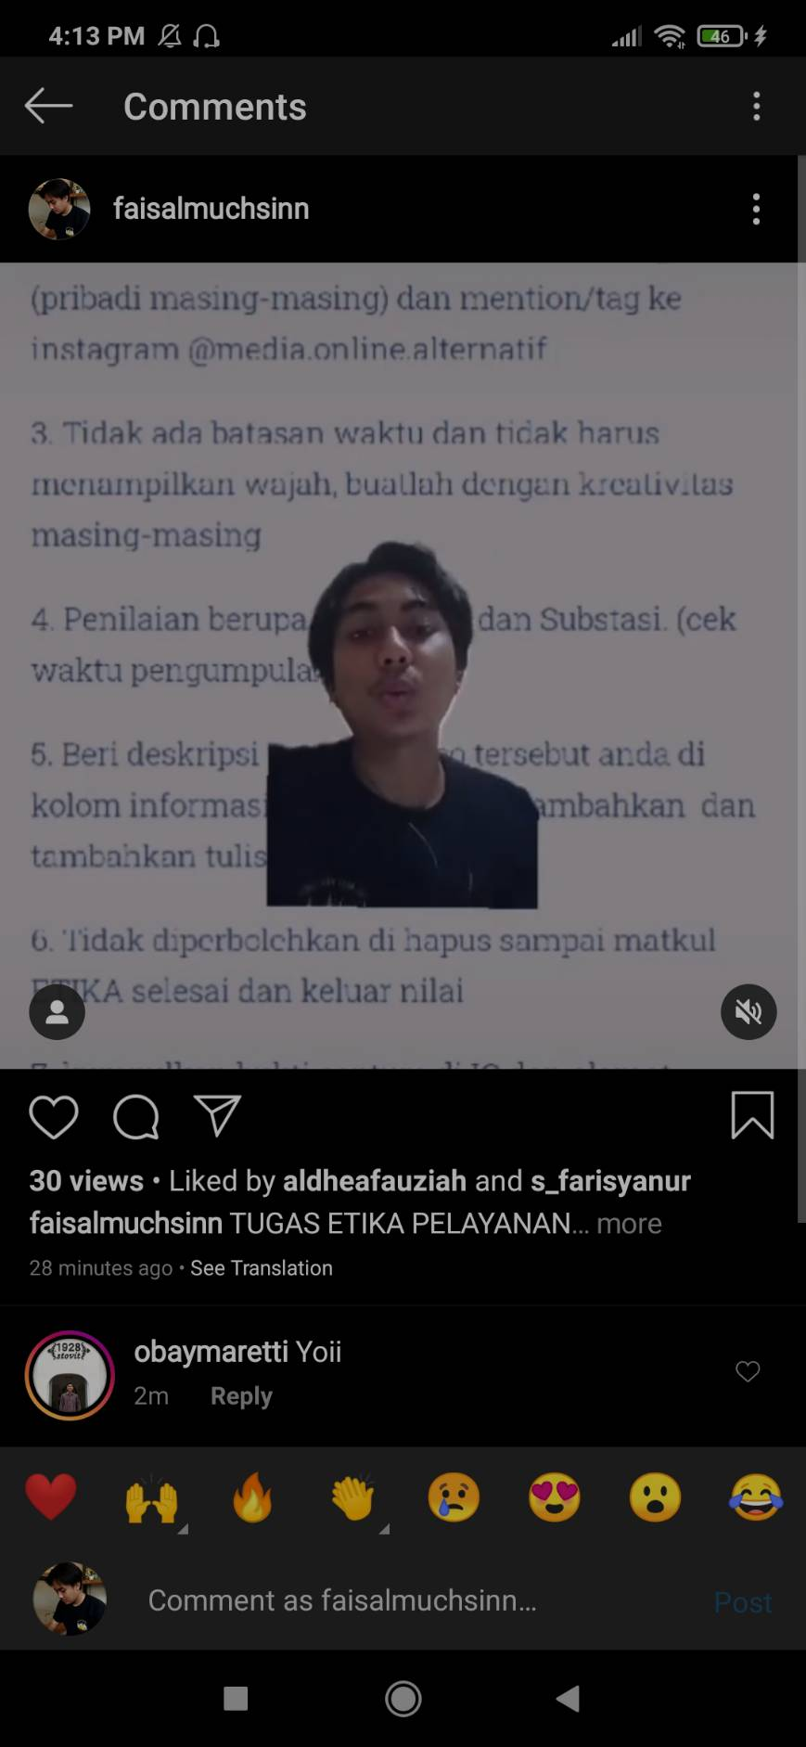

**BUKTI SUMBER FOTO**

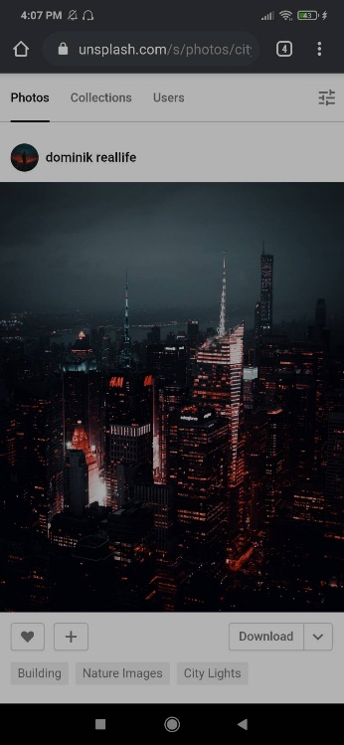 [**https://unsplash.com/@dominikreallife**](https://unsplash.com/@dominikreallife)

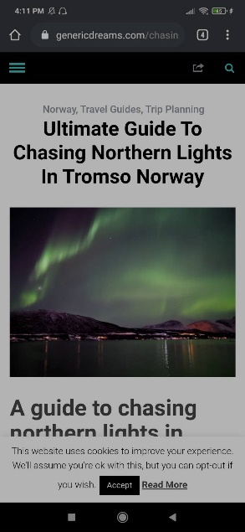 [**https://genericdreams.com/chasing-northern-lights-in-tromso-norway/**](https://genericdreams.com/chasing-northern-lights-in-tromso-norway/)

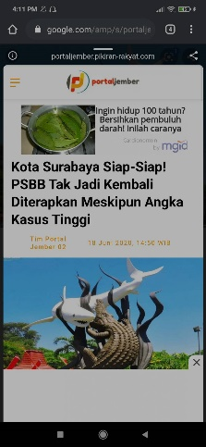 **https://www.google.com/amp/s/portaljember.pikiran-rakyat.com/regional/amp/pr-16567279/kota-surabaya-siap-siap-psbb-tak-jadi-kembali-diterapkan-meskipun-angka-kasus-tinggi**